Recent Deliveries

Rockwell Fall Ambulance Service

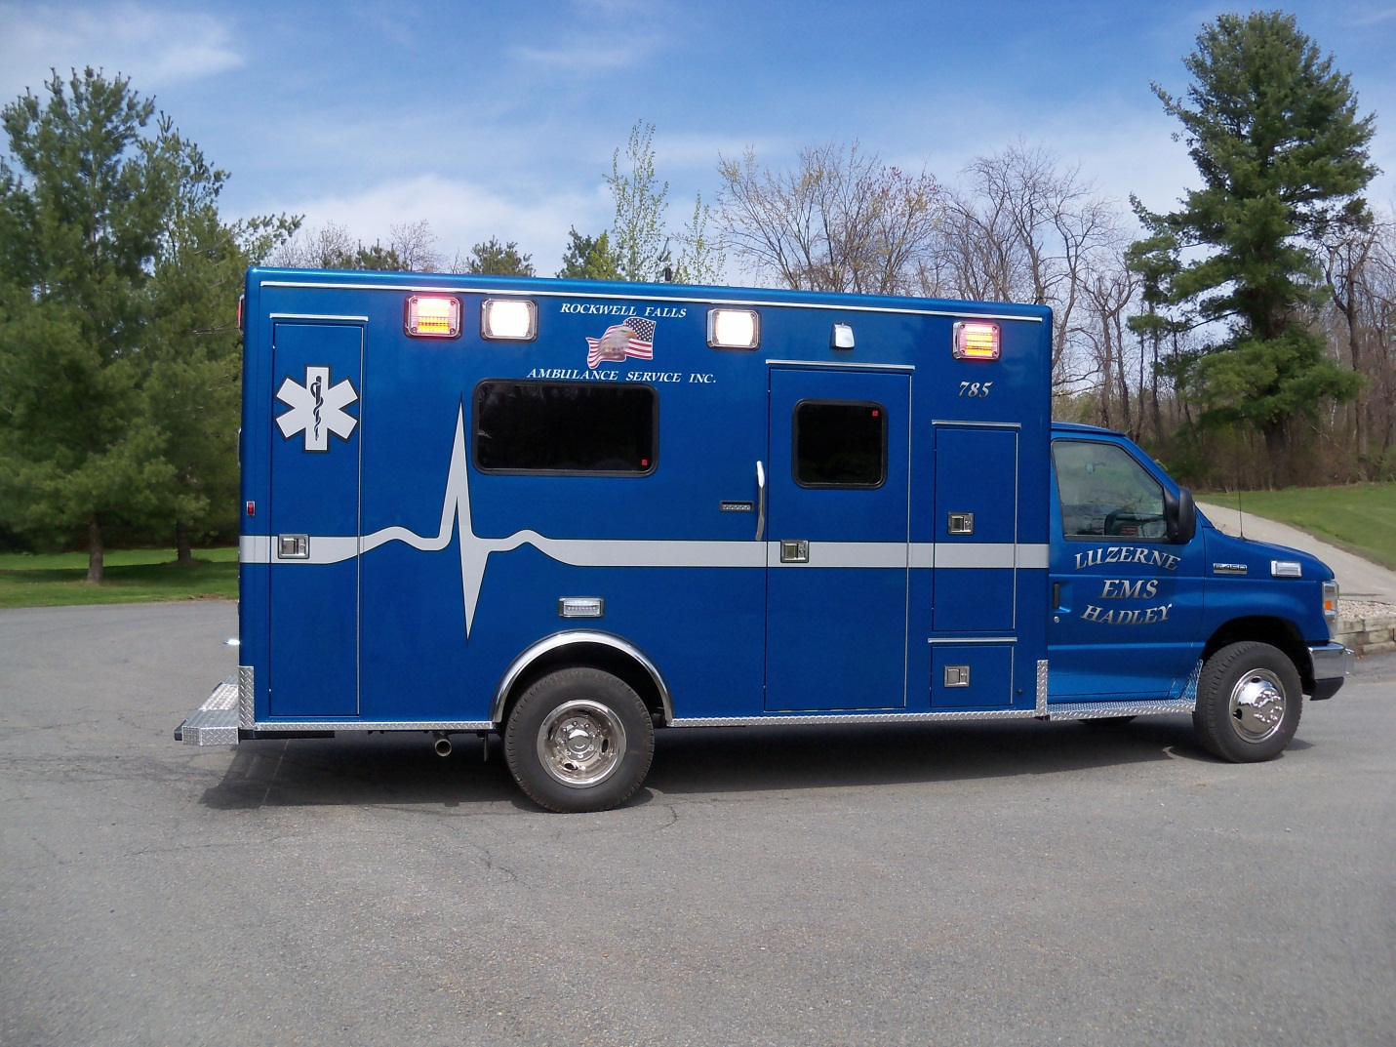

V.R.S. Sales Ltd www.vrs-sales.com 800-253-8572

